Gdb Use
After some modifications to the code and main, there was a memory leak in main
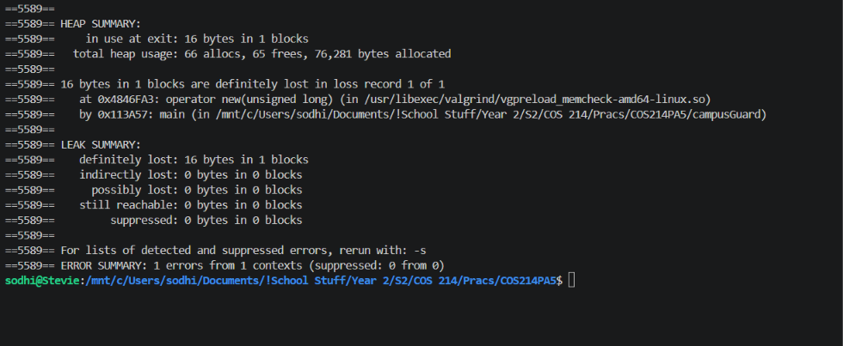
To find which variable was undeleted, we first thought to check which pointers aren’t null at the end. To do this, we set a breakpoint, then checked every pointer that was created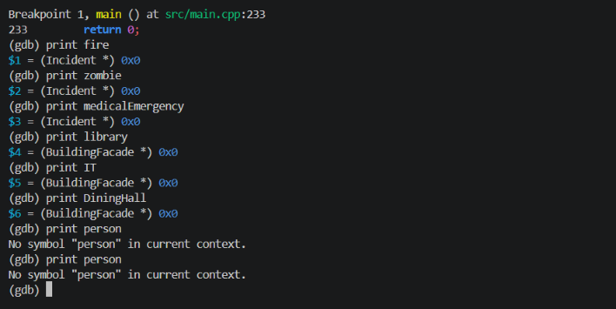
Person wasn’t showing up. Then we realised that it must’ve went out of scope, since it was created in an if statement, so gdb couldn’t see it, so we went and scanned the code, and saw we had not deallocated its memory, and did so.
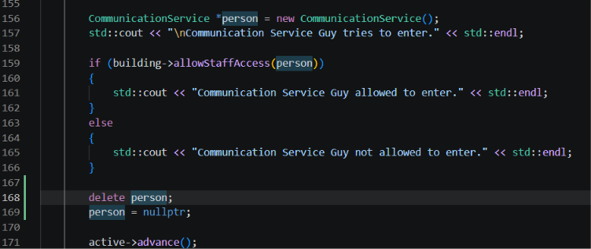
And now there are no memory leaks